Candidate number: 184737

Computer science  15/11/18

year 1 introduction to multimedia assignment 1 report

Contents

1. Introduction 2

2. Design & Development 3

2.1. Website Development 3

2.2. Animation Development 8

3. Conclusion 9

4. References 10

# Introduction

This report has been developed to accompany a website created for the first coursework hand-in for Year One Introduction to Multimedia. Featured in this report are the outlines of the design and development stages of the website development, which includes a number of important web and multimedia objects, including an SVG and JavaScript animation, and many HTML and CSS aspects. The purpose of this report is to highlight the methods and approaches that have been used to tackle the given task, as well as demonstrate how the specification points have been targeted and met. As a result, this report should show and prove that the website and animation in question have been developed to a good standard and that the design and development stages were successful in creating a final solution.

# Design & Development

## Website Development

The first step of design was to create a colour palette for the website. Using coolors.co (a colour palette generating website), a final colour palette was achieved, consisting of five colours – white and black, which were to be used mainly for text purposes; and three different green shades, which were to be used to break up the different content/sections on the webpage. White and black were obvious choices for text as they are the best colours for readability. The green shades all complement each other very well, and had distinct differences in darkness, which made for good and clear content separation.

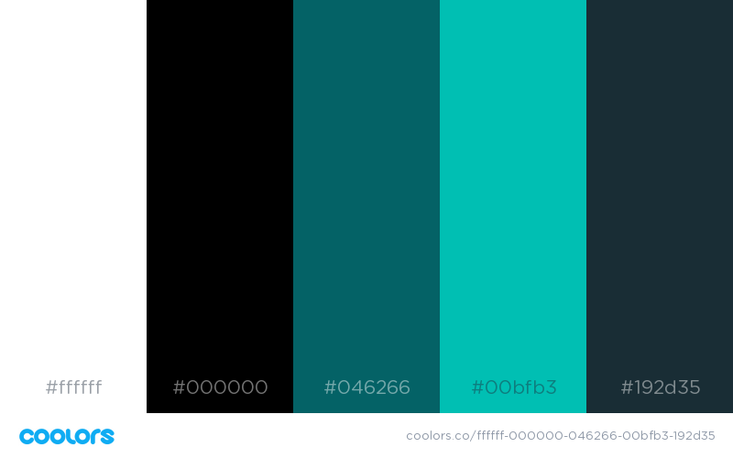

Figure : colour palette

For the webpage layout, the code used was structured into five main categories:

1. Navigation bar
2. Cover image
3. Title and introduction panel
4. Main section
5. Footer

These sections can be well observed on the ‘Coursework’ page.

Designing the website logo was the next step in the design process, which was achieved by using logo-app.ucraft.com, an online application dedicated to the development of professional looking logos. Once completed, the collection of images to be used across the website was the next item on the agenda. All images featured on the website have been gathered from pexels.com, a website featuring a collection of free to use photos and pictures that don’t require attribution.

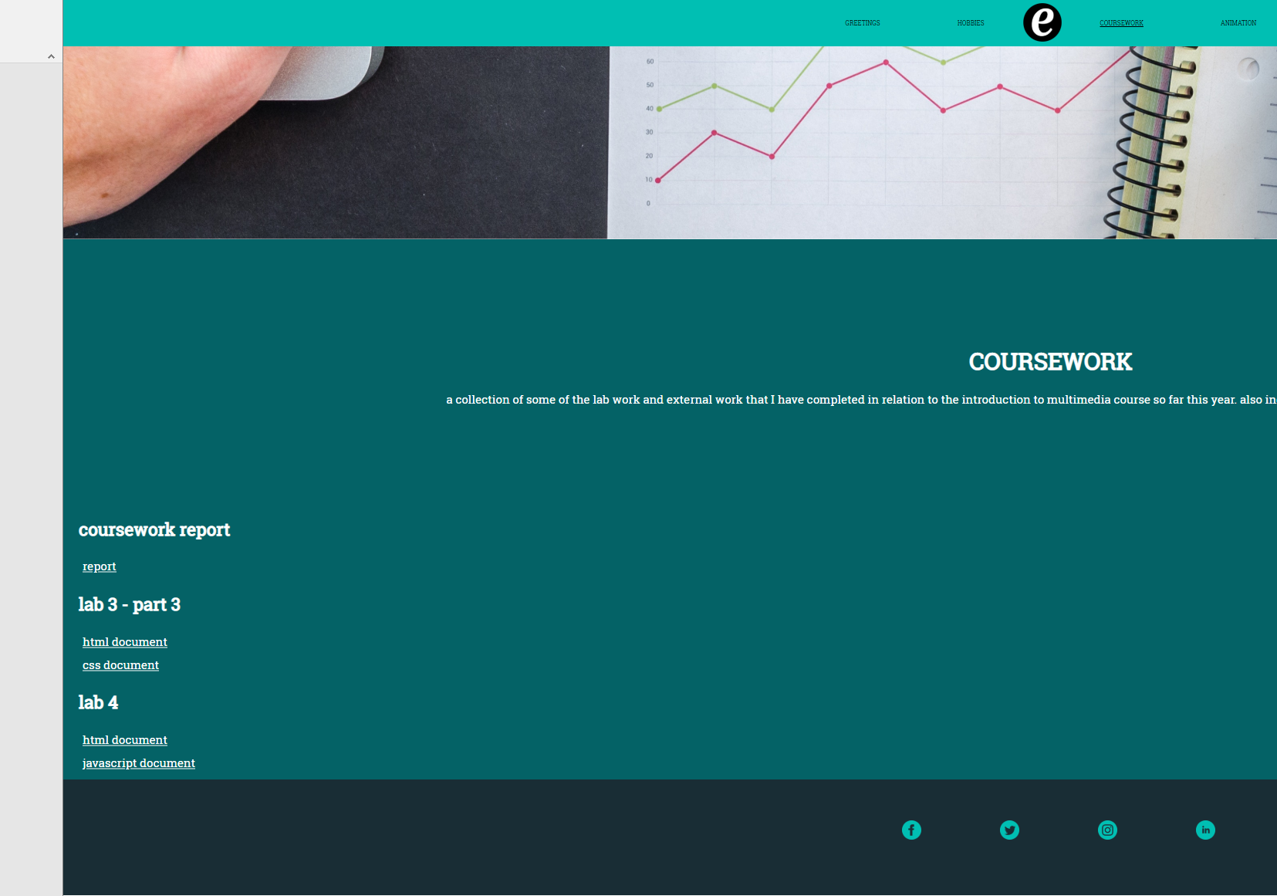

Figure - example of the five main content sections

A combination of HTML divs and ids were used to separate this content, with some of the content being consistent on each webpage and some of it differing from page to page. For example, the cover image on each page was contained within a div element whilst the title and introduction panel was contained within a class element.

Having five main sections is a good number, as it prevents the webpage from being over-cluttered and having too many sections spread out over it, which can make for a bad user experience. Oppositely, featuring five main sections helps to prevent the webpage from being too minimal and repetitive as it allows for different areas of the page to have different styling using CSS whilst remaining consistent across the website.

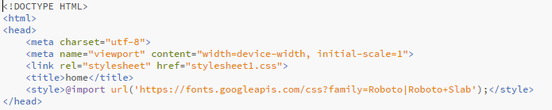

Figure - <head> contents for homepage

The HTML code in *Figure 3* remains consistent across all five webpages, with the only changing element being the title. The Roboto Slab font has been imported from the Google Fonts website.

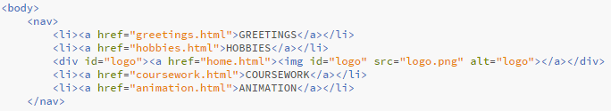

Figure - navigation bar HTML code

The next main section of the webpages is the navigation bar. This was developed by using the <nav> tags, which were then populated with list elements that all point to their relevant webpages, including the logo which directs the user to the homepage. A number of CSS styling properties were then applied to the nav, nav li and nav li a identifiers to get the bar to display its contents properly aligned and centred vertically and horizontally, and to also apply hover properties.



Figure - cover image div

As mentioned, each webpage features a specific image on it that acts as a banner image.

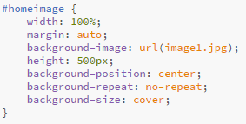

Figure - cover image CSS

As seen in *Figure 6* this cover image stretches the full width of the page, with a specified background image that is always 500px high.

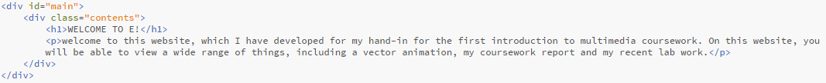

Figure - introduction section

The ‘main’ section of the webpage is used to introduce the specific page with a main title and short description or welcome message. It is also worth noting the ‘contents’ div class, which is used to contain all the content, media, etc. within the outer container. This class simply applies styling to align the content in the centre of the ‘main’ container both vertically and horizontally.

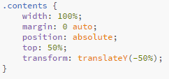

Figure - CSS for the contents class

The section for the main contents and text of the page is contained within the ‘panel’ class. This is simply a class that sits underneath the introduction section, that holds the main content. The container stretches 100% wide and is 700px in height.

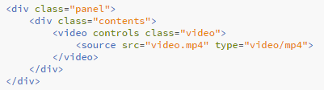

Figure - panel class

The last of the main sections is the footer. The footer simply contains a list of PNG items that all link to their related social media sites. It is worth noting that whilst these links only direct the user to the homepage of the specified social network, they would obviously point to an actual social media page if the website were to be properly published for commercial use.

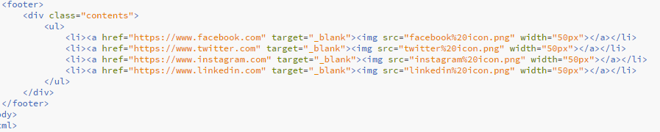

Figure - footer contents

Another thing about the footer worth noting is that each list element contains a target=”_blank” statement, which causes the hyperlink to open up in a new tab rather than in the current one, which improves user experience as it means that they don’t need to repeatedly go back and forth through the current tab using the back button.

The footer also makes use of the ‘contents’ class to make sure everything aligns and positions itself in the centre.



Figure - social media icons in the footer

The social media icons contained within the footer were taken from iconmonstr.com, which allows users to download icons for free for use in non-commercial and commercial projects without attribution.

As seen in *Figure 9* a video has been developed for the website. The ‘Greetings’ page features this video, which was made using Adobe Spark. The video was then embedded into the webpage and aligned and position using the ‘panel’ and ‘contents’ classes. The video class was then given the CSS properties of ‘width: 100%;’ and ‘max-height: 700px;’ to make sure the video player fit perfectly within the panel section of the website.

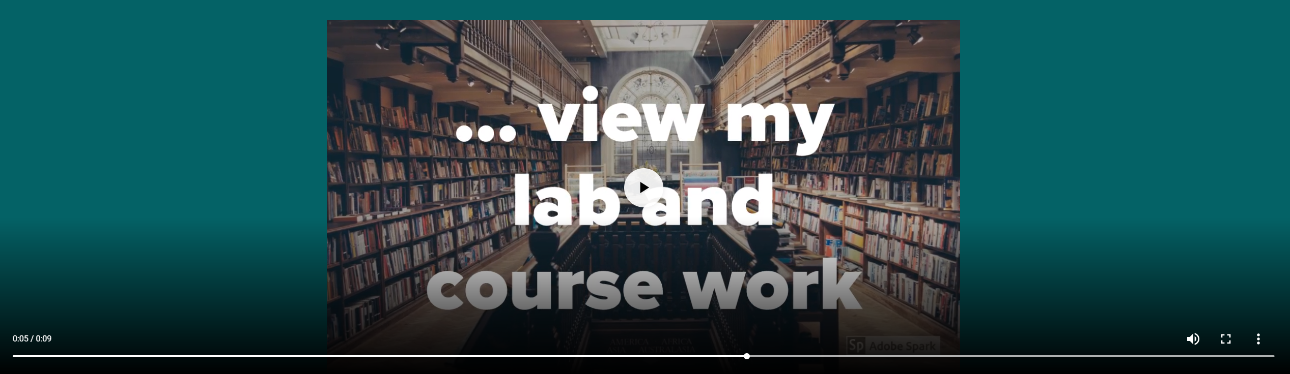

Figure - video player on the Greetings webpage

Another extra feature that has been added to the website are the hobby panels found on the ‘Hobbies’ page. Inspired by a W3Schools tutorial, these panels each have a text overlay which slides in over and covers the panel when hovered over. This is a way of presenting and describing the list of hobbies in a much more interesting and appealing way, rather than simply having a list or an image at the side of a block of text.

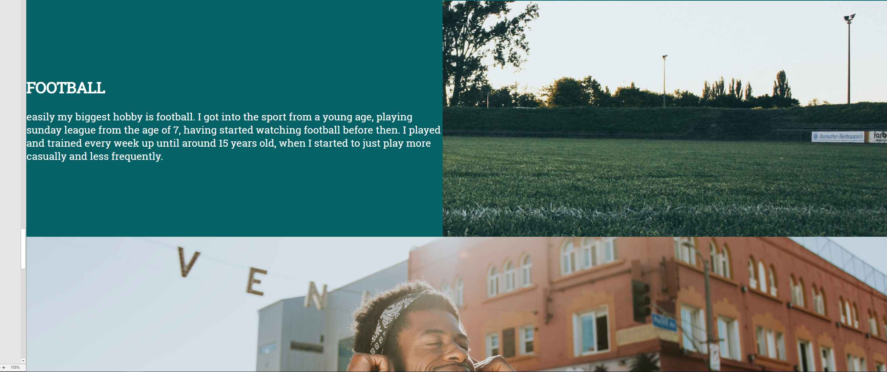

Figure - the football panel currently sliding in from the left over the panel

This effect was achieved by apply an overlay class to the specified div. The overlay takes the height and positioning of the parent div, with a width of 0% and an easing transition applied to it.

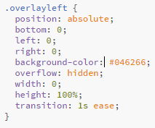

Figure - CSS code for the overlay

Then, when the parent div is hovered over, the overlay’s width is changed to 100%, causing it to transition and stretch across the page, which as a result displays the background and text.



Figure - overlay hover effect

## Animation Development

The animation was developed using SVG canvas and animated using JavaScript. The JavaScript was coded in an external file and embedded into the webpage. Unfortunately a lot of the project specification for the animation was not met due to a lack of ability and understanding using JavaScript animation. The audio file was successfully implemented. The animation does make use of a bitmap element, as well as two animated vectors, which include multiple shape/motion/colour changes. Another specification point that was not met was the requirement of the animation lasting longer than 10 seconds as it was not finished.

A function was developed for every movement, event or change that takes place on the animation timeline. The circle element starts at its starting position, which then moves to the right, before jumping and hitting the yellowbox variable causing yellowbox to bump up and then down, before the circle jumps down and continues moving right. Once the circle reaches its end point, it scales its x and y values by 2 and changes colour to red. This completes the animation iteration, which then causes the circle’s position, size and colour to reset.

# Conclusion

Overall, the project was successful. The website produced meets all of the main specification points, and a lot of time and effort has been put in to make the website look and function beyond what was required. The website appearance is consistent across the board, and this also applies to the website being viewed and used in different browsers. The website has been developed using Google Chrome, but works and looks exactly the same when opened using Microsoft Edge and Firefox, although the audio file in the animation doesn’t play in Chrome so that specific page will need to be opened in Firefox instead. A number of features have been added to the site outside of the specification that enhance the user experience and functionality of it, including hover elements and overlays.

The aspect of the project that lets down the overall success of the project is the animation. A lot of time and effort was put into this, but unfortunately due to the difficulty of it and the time constraints it was unable to be completed, which meant that multiple specification points were not met. Despite this, a reasonable and working attempt was still produced and added to the website, and the majority of specification points are still met.

Having had some more time to learn and implement some other features, there are quite a few improvements and fixes that would be made. The most obvious of these improvements is the SVG and JavaScript animation. Enhancing this would be achieved by getting the audio to successfully sync with the animation. Having the current animated vectors do some more complex animations and transforms would also not only increase the complexity of the animation, but also lengthen it, which would further meet some more specification points. A more professional and clean looking animation would also likely be more appreciated by users of the website, which would be another improvement.

Another implementation that could have been added to further improve the project is the usage of more web development languages. For example, PHP could be implemented to connect the website to a database, which would allow the creation of a small web application or game, such as a clock or a counting game.

# References

M. Mueller. *Pexels.*[Online] Available from: <https://www.pexels.com/photo/adult-business-computer-contemporary-380769/> [Accessed 02 Nov 2018].

D. Tong. *Pexels.* [Online] Available from: <https://www.pexels.com/photo/66134/> [Accessed 02 Nov 2018].

JESHOOTS.com. *Pexels.* [Online] Available from: <https://www.pexels.com/photo/blur-close-up-device-display-442576/> [Accessed 02 Nov 2018].

M. Spiske. *Pexels.* [Online] Available from: <https://www.pexels.com/photo/black-and-white-soccer-ball-on-green-grass-land-during-daytime-114296/> [Accessed 02 Nov 2018].

Rawpixel.com. *Pexels.* [Online] Available from: <https://www.pexels.com/photo/man-smiling-while-listening-to-music-1371177/> [Accessed 02 Nov 2018].

K. Rocha. *Pexels.* [Online] Available from: <https://www.pexels.com/photo/adult-blur-camera-casual-598917/> [Accessed 02 Nov 2018].

Lukas. *Pexels.* [Online] Available from: <https://www.pexels.com/photo/person-writing-on-notebook-669615/> [Accessed 02 Nov 2018].

L. Cafaro. *Pexels.* [Online] Available from: <https://www.pexels.com/photo/239898/> [Accessed 02 Nov 2018].

Iconmonstr. Social media. *Iconmonstr.* [Online] Available from: <https://iconmonstr.com/?s=social+media> [Accessed 02 Nov 2018].

W3schools. How TO – Image Hover Overlay. *W3schools.* [Online] Available from: <https://www.w3schools.com/howto/howto_css_image_overlay.asp> [Accessed 02 Nov 2018].